Marrapu Sai Narendra

**Full Stack Web Development (AMJ24)**

**Aim of the project:**

The main aim of this project is to showcase our html and css skills by creating a restaurant website which has the details and

The items that are provided by specific restaurant in that

RESTAURANT WEBSITE

Objective:

The main purpose of creating this website is to Showcase our html and CSS skills. This is just a website which is used to know about a specific restaurant.

Abstract:

An online Restaurant website enables ease for the customer’s online information get on your stress free from restaurants as well as confusion service. These systems improve the procedure of delightful the order as of customer. The online restaurant website set up an about a location and about of options online and customers can easily place know this Restaurant site.

Outputs:

Home Page:

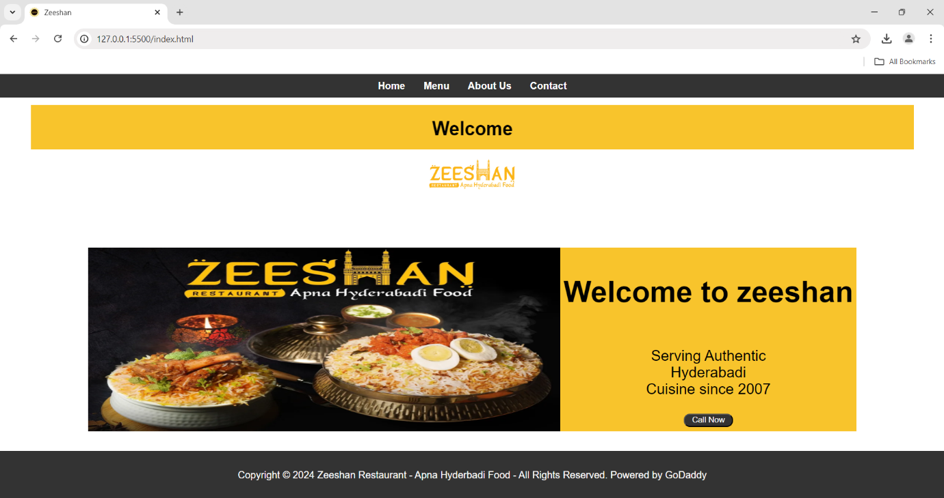

Menu Page:

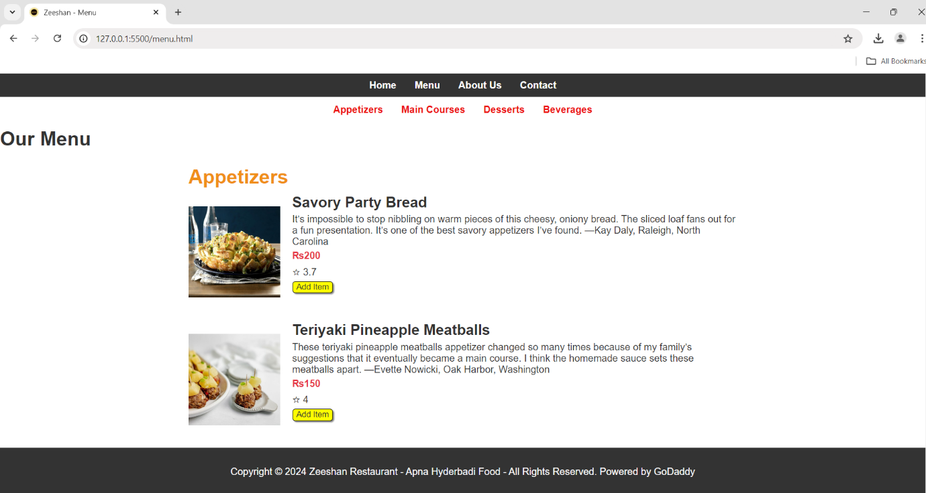

About Page:

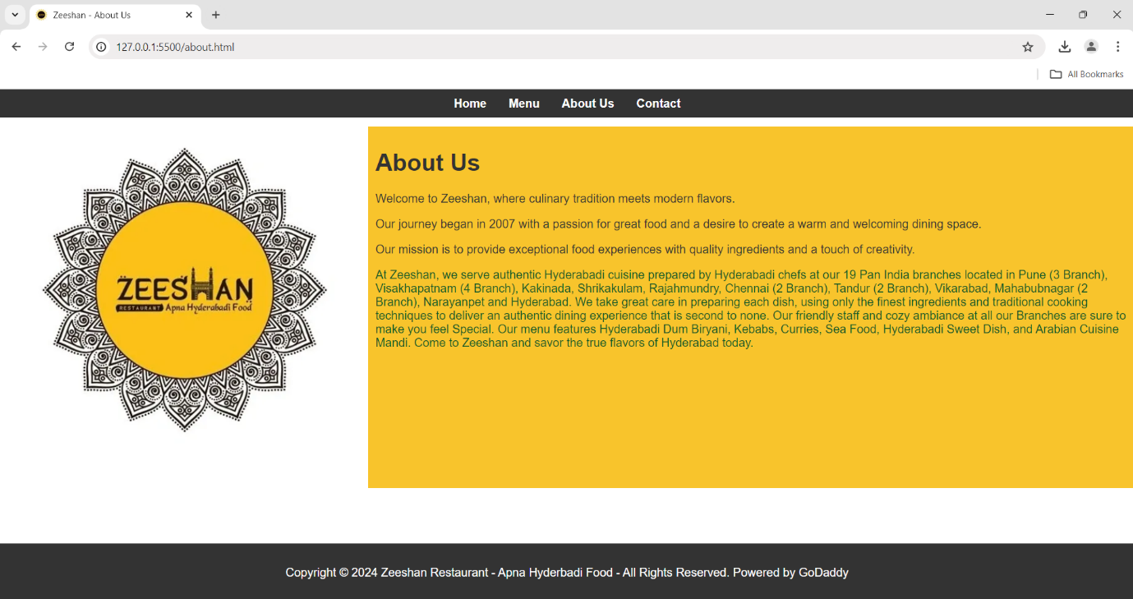

Contact Page:

